5 /10 Year Plan 2018-2023
Prepared by: Rev. Mike Deed, on behalf of the leadership of Church of the Resurrection

Church of the Resurrection
Edited 2019.12.03 by E. Clare Stewart & Carl Sneyd on behalf of the Parish Council of Church of the Resurrection

INTRODUCTION
Having a plan is quite simply good stewardship. It’s a way of honouring what God has given us, being intentional about God’s mission and our part in it and putting in place the right preparation to help that mission thrive.

A plan is by no means carved in stone: As our church and situation changes and as we become more aware of God’s work among us we can adapt and change it. However, having a plan is like a road map to keep a community of faith journeying together. It will help us make decisions, to say ‘yes’ to things that fit the plan and ‘no’ to things that don’t with some degree of confidence and clarity.

One challenge is that a good plan for church growth has to take many things into account and weave them together, like having four strands woven together to make a rope.

• The plan is primarily to help us engage with the mission of God at work in the world God loves so SPIRITUALITY is a key part of that plan- we need to ask the question, ‘what are the signs that our community is growing and deepening its faith?’

Church of the Resurrection
• From spiritual growth should flow a change in action, an evolution of MINISTRY.
• As our ministry changes and grows so it will make a demand on our PHYSICAL resources and so the building and staffing will be part of the plan.
• And of course making it happen requires people, talent and finances and our STEWARDSHIP of these things is vital to support all of the above.

SPIRITUAL GROWTH
“You also, like living stones, are being built into a spiritual house to be a holy priesthood,
offering spiritual sacrifices acceptable to God through Jesus Christ.” 1 Peter 2.5

What are the signs of Spiritual growth in a church?
Anything we do as a Church will flow from our Spirituality- what it is we believe God is about, what God is calling us to be and how God is changing us. We cannot mandate spiritual growth, but we can ask the question what it looks like and how we might nurture it?

What are some of the signs of Spiritual Growth:
  - Changed lives
  - Passionate worship
  - Creativity
  - Culture of encouragement
  - People engaging in personal discipleship
  - Active and intentional prayer ministry
  - Faith Sharing
  - Comfort articulating one’s faith
  - Asking Questions.
  - Devotion Sacrament / prayer / study of scripture
  - Increased Generousity
  - Culture of welcome and hospitality
  - Humility and service
  - Joy
  - Patience
  - Peace & peace making
  - Kindness
  - Communal Pastoral Care
We could list many more.

Church of the Resurrection

How might Spiritual Growth be Nurtured?
- Create Bible Study groups
- Tell Stories
- Try different forms of worship
- Sermon series
- Spiritual Gifts survey
- Encourage use of Parish Library
- Provide resources and opportunity to purchase
- Engage more people in church activities.
- Expand our repertoire of worship styles
- Offer more educational courses on faith issues.
- Create prayer groups / small groups / house groups.
- Provide seasonal prayer resources
We could list many more.

MINISTRY GROWTH
“As the body without the spirit is dead, so faith without deeds is dead.” James 2.26

There are infinite ideas for ministry; it’s easy to look at what is successful elsewhere and want to copy it. But the very foundation of our faith is ‘incarnation’. Mission needs to grow and flow naturally from our Spiritual growth in our own context. So we may decide that an area of ministry needs to grow and we will plan the first steps with education, prayer, and stewardship and first actions and then nurture ministry as what God does among us becomes apparent.

PHYSICAL PLANT
“Then He said, "Do not come near here; remove your sandals from your feet,
for the place on which you are standing is holy ground." Exodus 3.5

Our Building is a spiritual home, a resource for us to incarnate the Spiritual growth and ministry of God’s Church. It is Sacred Space. This does not mean it is unchanging, but rather it adapts to help us understand, locate and respond to the presence of God and we understand that there are many ways to do this. It is also a gift entrusted to us for a time and something we hand on to the next generation of the Church as they share in leading the mission.

Church of the Resurrection

The physical plant must be maintained according to our mission and purpose. The building speaks a language- either it will reflect what we understand ourselves to be (safe, welcoming, inviting, hopeful, equal, inclusive) or it may reveal us to be hypocrites. Our building also has issues to address so that we don’t hand on problems to the next generation (like the asbestos).

Anglicans are very attached to their buildings. This has good and bad consequences; when the building fails to help us serve the mission of the Gospel it may be time to uproot ourselves and, like the Israelites pitch a new tent with God.

STEWARDSHIP
“As each one has received a special gift, employ it in serving one another as good stewards of the manifold grace of God. Whoever speaks, is to do so as one who is speaking the utterances of God; whoever serves is to do so as one who is serving by the strength which God supplies; so that in all things God may be glorified through Jesus Christ, to whom belongs the glory and dominion forever and ever. Amen.” 1 Peter 4.10-11

For all of our future plans to come about it must be carefully and wisely supported by our stewardship. This is not just financial, but also our time, energy, talent, skills. Stewardship weaves through the spiritual, ministry and building work of Resurrection. Stewardship is a spiritual discipline that is enacted individually and corporately. Leaders must take responsibility for nurturing it, modelling it, being transparent and humble, and shaping it with invitations, thanksgiving, encouragement, gratitude, and purpose.

Church of the Resurrection

Stewardship planning may include:
- Volunteer management
- Volunteer appreciation
- Clear financial goals and strategy
- Communication
- Bold asking in faith
- Gift recognition
- Internal fundraising
- External Fundraising (grants)
- Ministry Recognition and visioning
- Staff management
- Building maintenance
- Education
And more….

TIMELINE
“There is a time for everything, and a season for every activity under the heavens” Ecclesiastes 3.1
Putting in place a 10 year plan will give us focus and a sense of purpose and priority. While the first five years may be somewhat detailed, a review point at the 5 year mark will allow us to reassess our progress and clarify the next 5 years.

UNDERLYING SUPPOSITIONS
“And no one pours new wine into old wineskins. Otherwise, the wine will burst the skins, and both the wine and the wineskins will be ruined. No, they pour new wine into new wineskins." Mark 2.22

Achieving significant growth in all the areas detailed above will necessitate a change in the practices and expectations of our community, including:

• The future will be talked about more than the past.
• The plan is a collective responsibility not a job description for the clergy or corporation.
• Encouragement will be a first reaction before criticism.
• Leadership needs to work as a cohesive team: Parish Council, Lay Readers, Clergy and Corporation. These groups will stay ‘on message’ together and model good practice and community.
• The Role of the Rector will change with the priorities of the plan, traditional expectations may have to evolve or be abandoned.
• The Church mindset of ‘going with the cheapest’ will need to change to ‘going with what’s best’ and long term plans for replacement and maintenance will be created.
• We will learn to say ‘no’ to people, ideas and opportunities.
• There will be fewer committee meetings; a culture of ‘doing together’ rather than ‘meeting together’ must prevail.
• Staff must be well supported.
• ‘Change’ will become normal and celebrated with healthy reviews and constructive criticism.
• New technology will be embraced.
• The mission is sacred, the method is not.
• The mission must take priority over personal preference.

Where do we start?
We have already started:
• We started when a new Parish was established and called ‘Church of the Resurrection’.
• We have taken steps towards our plan in recent years, articulating a vision statement and defining our seven areas of ministry.
• We have started new outreach and justice programs and made connections and partnerships in our local community.
• We have changed the format and make-up of Parish Council to bring all our leaders together in the context of worship and a focus on our vision.
• We have made conscious decisions to STOP certain ministries.
• We have been paying more attention to our volunteers.
• We have restructured our budget around our ministry areas and we have held regular meetings to ensure everyone knows our situation and can contribute, ask questions and share wisdom.
• We have empowered new people to leadership.
• We have given careful attention to our building, with every room being painted within four years and vital maintenance carried out.

The next steps are to start exercising our imaginations, articulating the 10 year plan, giving it form and agreeing upon our priorities.

Is this realistic?
Glory to God, whose power working in US
can do infinitely more than we can ASK or IMAGINE.
Glory to God from GENERATION TO GENERATION
In the Church and in Christ Jesus, forever and ever. Amen.

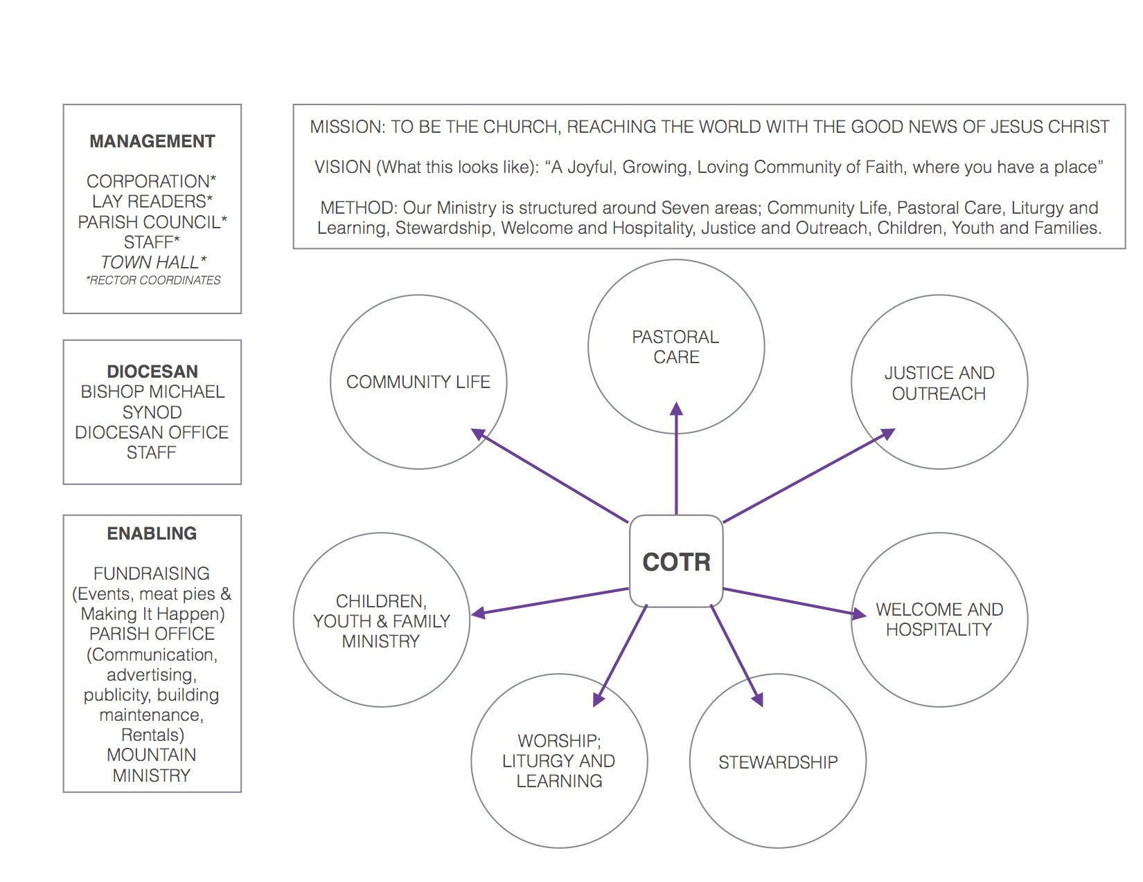
OVERVIEW
DIOCESAN
BISHOP SUSAN
SYNOD
DIOCESAN OFFICE
STAFF

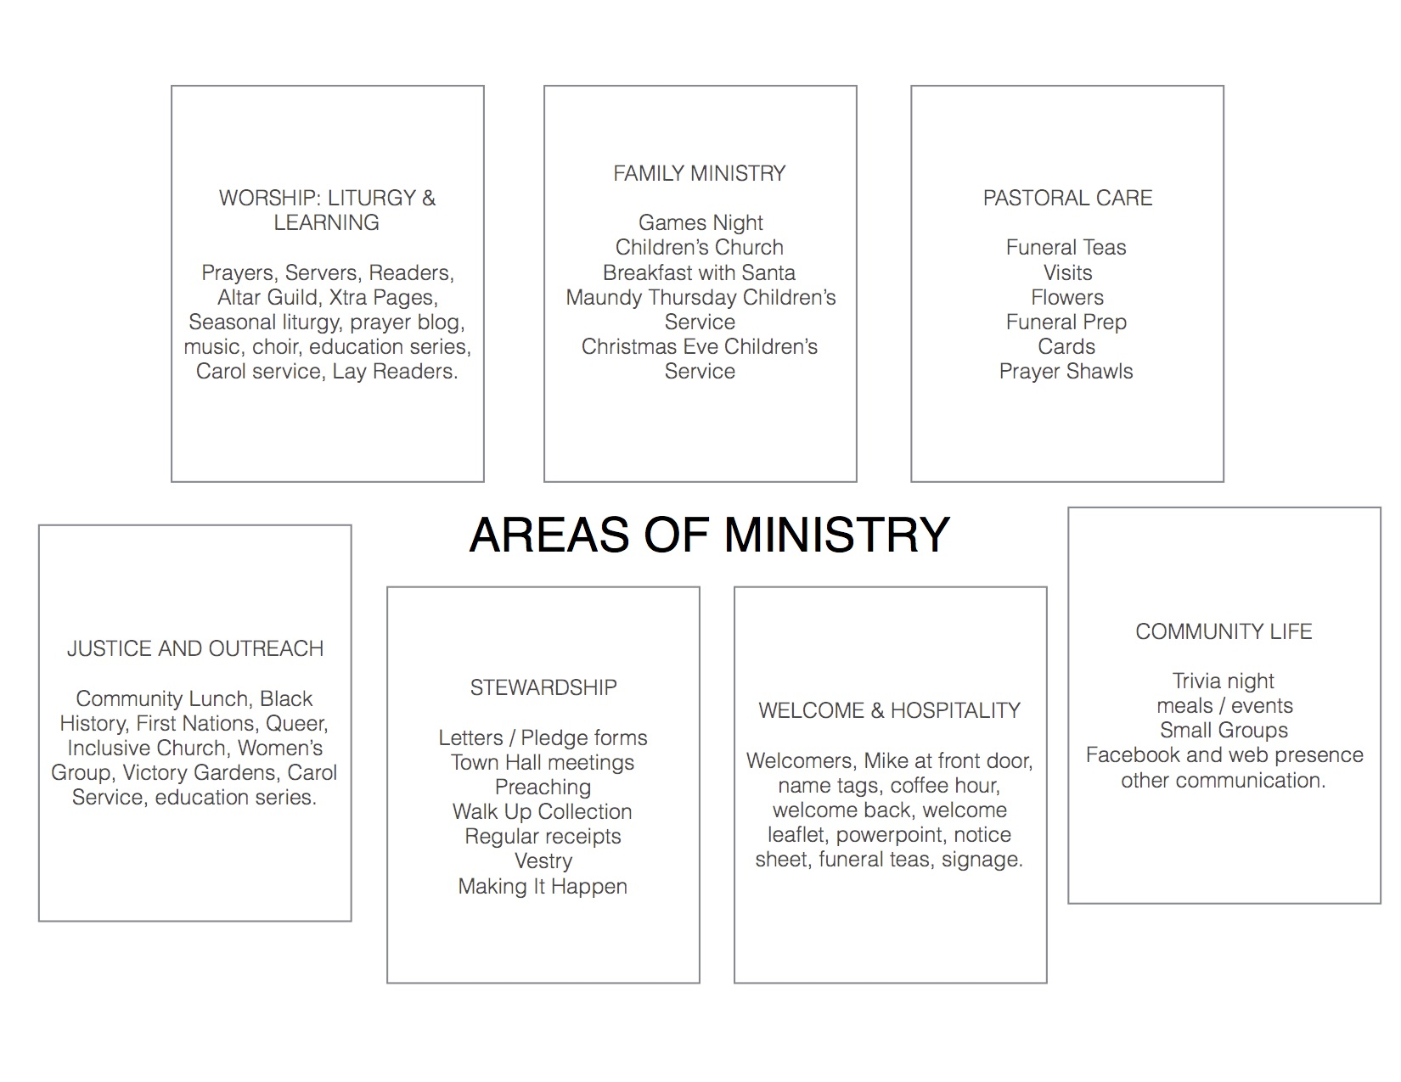

OVERARCHING PRIORITIES
There are a number of goals that we wish to establish that will serve to support and serve the development of all areas of ministry.
Church of the Resurrection
OUR BUILDING
A review by the Parish Council of Church of the Resurrection was part of an extensive discussion at our 2018 vision day. This formed one part of a far larger conversation over many months about our ’10 Year Plan’.
We recognized the amazing resource we have in our building. We gave thanks to God for the many things it enables us to do and how it has housed our changing community of faith over the past 18 years and another parish previously.
For each part of the building we asked:
- What is it?
- How does it bless us and benefit the mission of the church?
- What are it’s limitations or draw backs?
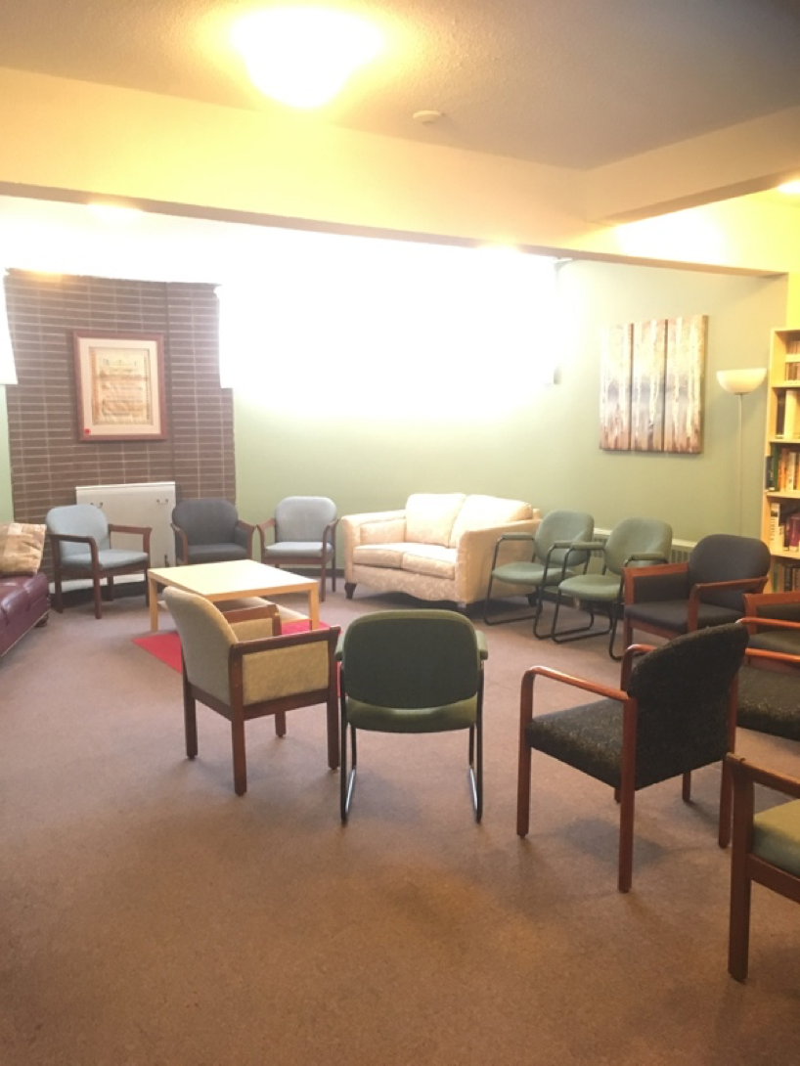
- And what could we do differently or better with this space / what improvements could we make?

What is it?
The Fireside Room (in basement)
Education Room, Meeting Room, Parish Library, Black history Library, Lounge, Meeting Space, Scullery!

How does it bless us and benefit the mission of the church?
- Multi Purpose
- Cosy Space (we don’t have many in the building)
- Access to Mohawk Room Kitchen
- Warm space in winter
- Intimate gathering space
- Comfy
- A primary meeting Space
- Quiet space.
- Repainted in recent years with pictures and new bookcases and newer chairs.

What are its limitations or draw backs?
- Size and Shape (curved end limits set up)
- Too much furniture
- Carpeting / Flooring is dirty, dated and damaged.
- Too warm in summer, poorly ventilated.
- Not accessible, very visible, poorly signed.
- Lower hallway leading to this room is dark and cold and feels dirty.
- No common set up- people leave this room untidy.
- Lighting is poor and from the 60’s. Is it Green??
- Narrow corridor leading to this room.
- No obvious space for screens or projection or presentations.
- Poor access to washrooms especially when Daycare is in progress.

What could we do differently or better with this space / what improvements could we make?
- Remove the sofas
- Replace flooring with hardwood / vinyl / laminate for ease of cleaning.
- New brighter and dimmable lights.
- Blow out the neighbouring office wall and make it bigger.
- Add in technology; screen and projector.
- New windows, new curtains.
- Better signage
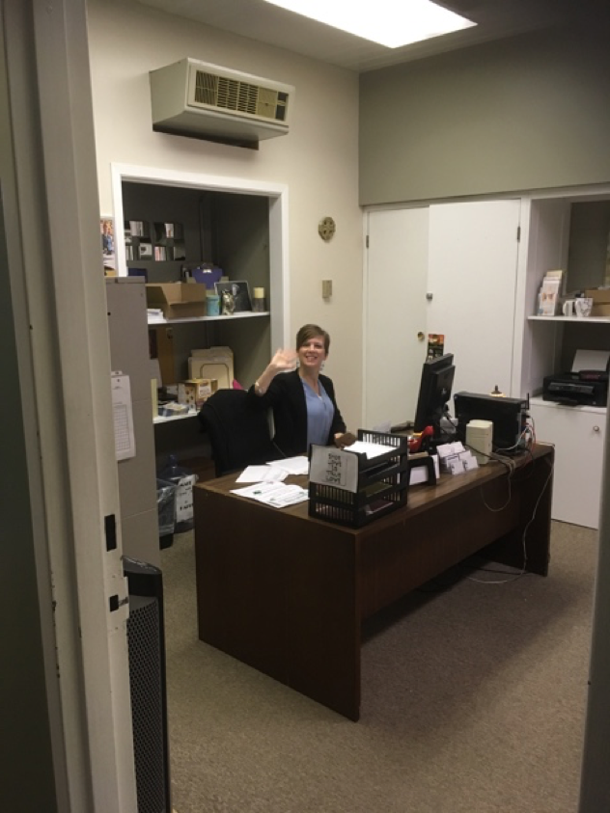
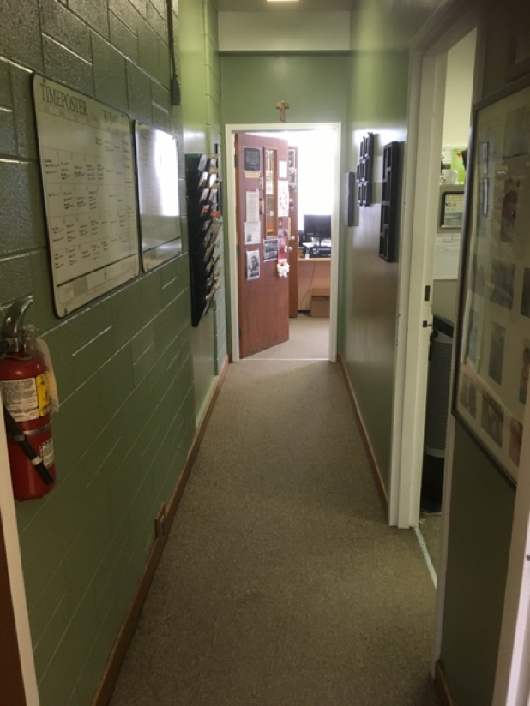
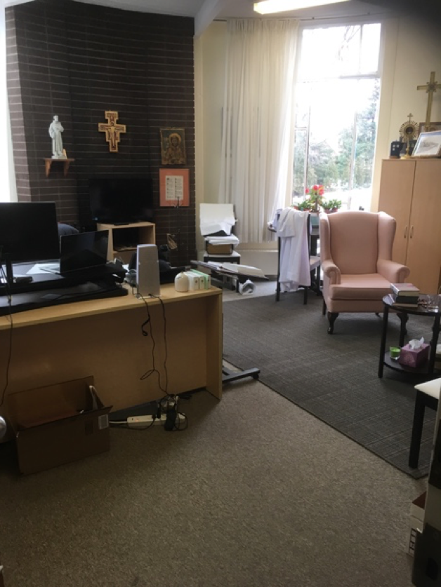
- .

What is it?
- Rector’s Office, Main parish office and Hallway.
- (meeting space, administration, communication)

How does it bless us and benefit the mission of the church?
- Administration
- Financial Administration
- Printing
- Planning
- Privacy
- Pastoral space
- Storage of resources
- Printing
- Internet and technology hub.
- Communications
- Rentals coordinated
- Welcome to our church- connect with the office.

What are its limitations or draw backs?
- Temperature is uncomfortable.
- Paper dust / storage is unhealthy
- Easily crowded space.
- No ‘waiting room’
- Wall file folders are an eye sore.
- Rector’s office has windows in need of repair.
- Hallway is dark and narrow, uninviting.
- Very little natural light in the main office.
- Not enough storage.

What could we do differently or better with this space / what improvements could we make?
- Improve security.
- Replace the windows in Rector’s office.
- Replace flooring for easier to clean.
- Repaint common paint theme- lighter.
- Enlarge office- perhaps remove wall to corridor?
- Better lighting.
- More power points in Rector’s office.
- Update furniture.
- Relocate file folders
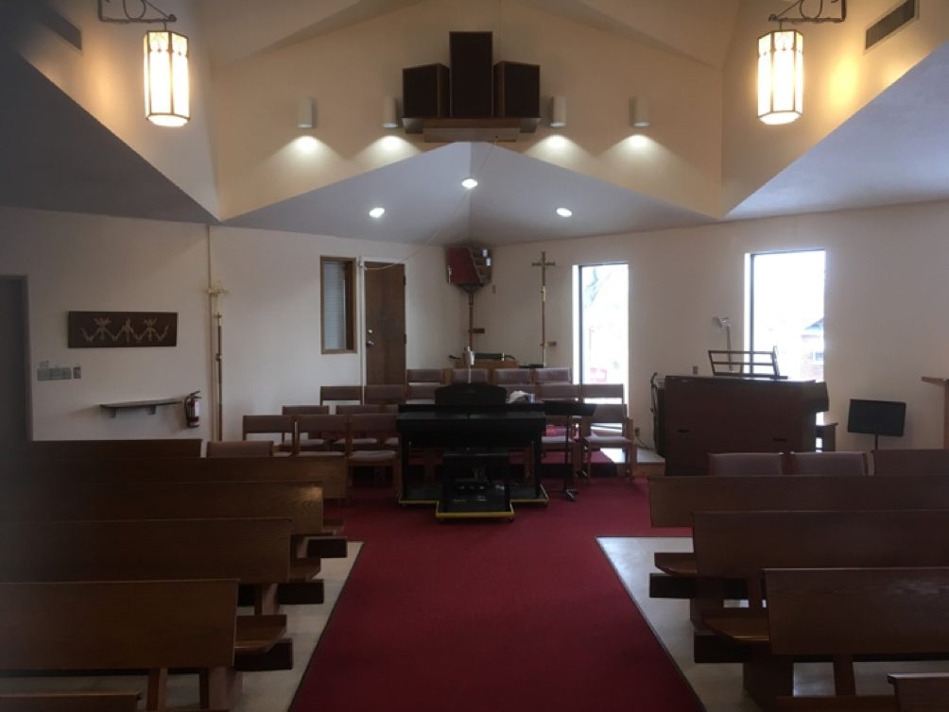
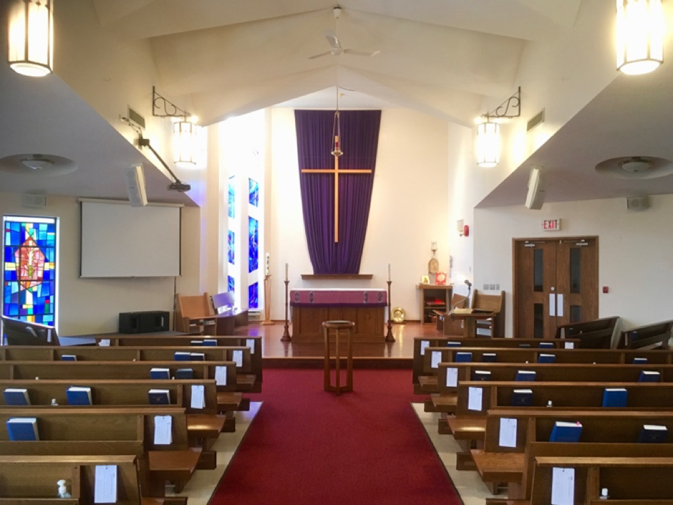
- .

What is it?
- Sanctuary, Worship Space, Prayer space, Choir area, AV room and resources.

How does it bless us and benefit the mission of the church?
- Primary gathering of the community.
- Primary space for communal worship
- Concerts, lectures, education.
- Dedicated to worship.
- Good visibility.
- Light, modern worship space.
- Images / Icons

What are its limitations or draw backs?
- The doors are usually locked for security- we cannot see the church from the office.
- Fixed seating limits the use of space for new or creative ministry and worship.
- Fixed seating limits discussion.
- Screen not visible at all angles
- Lighting switches old and inefficient and frustrating.
- Piano limits movement.
- Number of choir members limited by their space.
- Is the lighting ‘green’.
- The lighting is not flexible- no ambience. Poor for concerts or lectures, Carol services and performances.
- Ceiling limits acoustics to one shape.
- Dated organ.

What could we do differently or better with this space / what improvements could we make?
- Movable Seating / Chairs in place of pews to create flexibility.
- Cleaning.
- New flooring.
- Variable lighting including directional lighting.
- More screens visible throughout worship space.
- New piano - DONE
- Create ‘Church in the Round’
- Fix AV room storage A WORK IN PROGRESS
- Create ‘prayer ground for children’. DONE
- Move choir to front.
- Blow out the walls, reconfigure entrance, create larger open space.

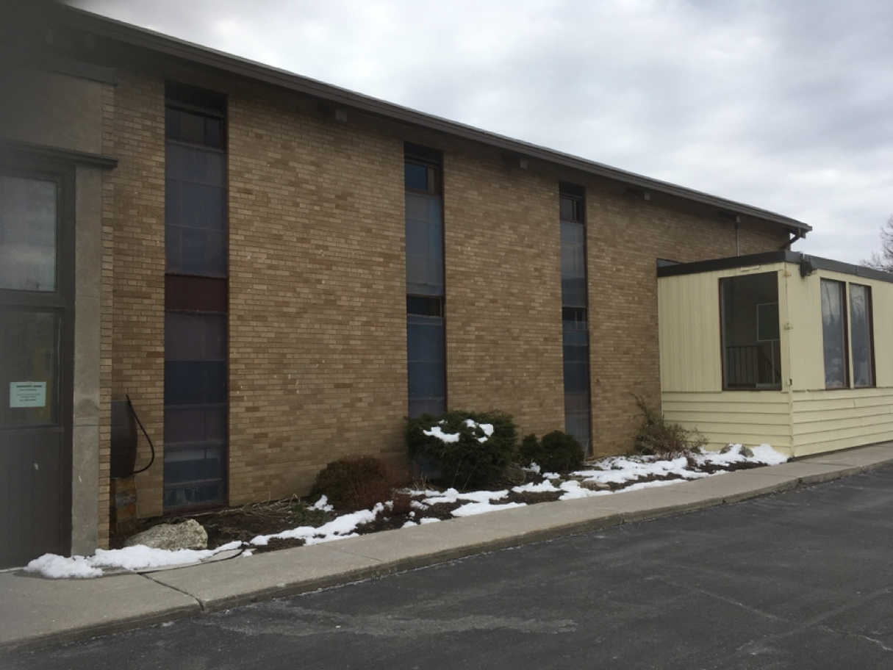

What is it?
- West side of Canterbury Room
- South West ‘Garden’
- Rear exit form building
- Driveway
- Main entrance to worship space
- Most visible side of our Building.

How does it bless us and benefit the mission of the church?
- Makes us visible to the community.
- Good location on major road.
- Fire Exit
- Main entrance says who we are.
- Cheery garden space in Spring / summer.

What are its limitations or draw backs?
- Narrow Sidewalk
- Ugly construction, uninviting
- Steep steps, inaccessible.
- Whole building inaccessible without elevator.
- Wire glass, broken glass ugly.
- Unused entrances.
- Limited messages to community possible.
- Doesn’t look ‘Church-like’
- Mix of buildings (60’s & 80’s) visible.

What could we do differently or better with this space / what improvements could we make?
- Better Signage
- Better security
- Ramp all entrances
- Greening
- Improve the front entrance, make it more welcoming.
- Seasonal decoration
- Remove Canterbury Stairwell
- Tear down half of Canterbury Room, create more parking.
- Extend building.
- Sell it all and move further south!
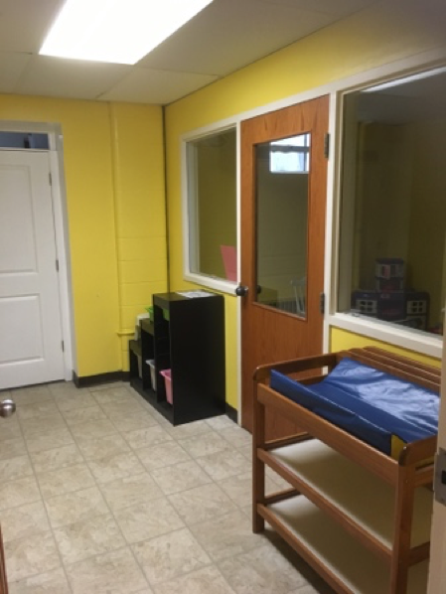
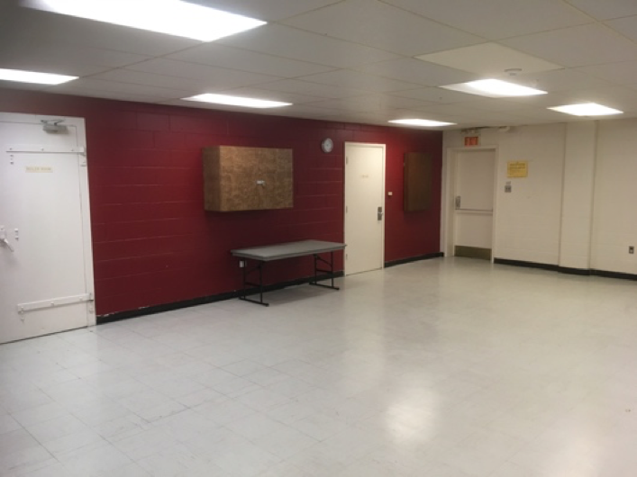
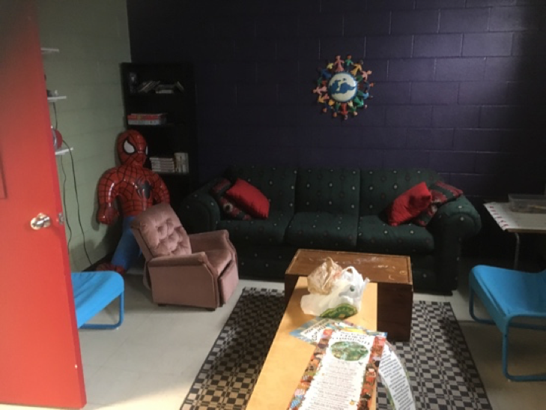

What is it?
- Basement of the old Church building
- Niagara Room, Youth Room, Nursery, storage space.
- Former vestry. Boiler room.

How does it bless us and benefit the mission of the church?
- Storage for the Altar Guild, centralised in one place.
- Community Space
- Sewing Group held here
- Nursery with washroom is a benefit.
- Cheerful colours.
- Youth Group designated meeting space.
- Rental space for small groups.

What are its limitations or draw backs?
- Asbestos insulation.
- Ceilings are low.
- Floor is bad.
- Nursery is too far from the worship space.
- Parents are too far from babies.
- It is underutilized space.
- Bathroom only accessible from nursery.
- Narrow entrance; extra corridor- we have so many corridors!
- Youth room and nursery have poor lighting and power supply.

What could we do differently or better with this space / what improvements could we make?
- Upgrade floor, lighting etc.
- Repurpose it.
- Address accessibility.
- Create new entrance.
- Reorient washroom to be accessible.
- Add new washroom.
- Refloor.
- Set up for meeting space- projector, screen, sound etc. –DONE (Partially)
- Knock through youth room and nursery to create bigger space.

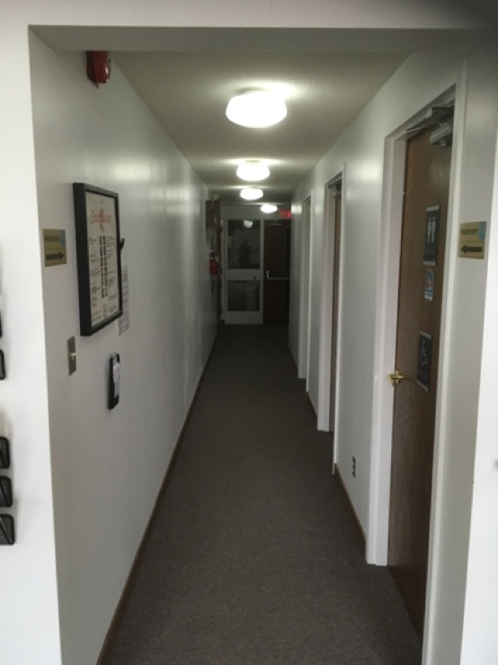
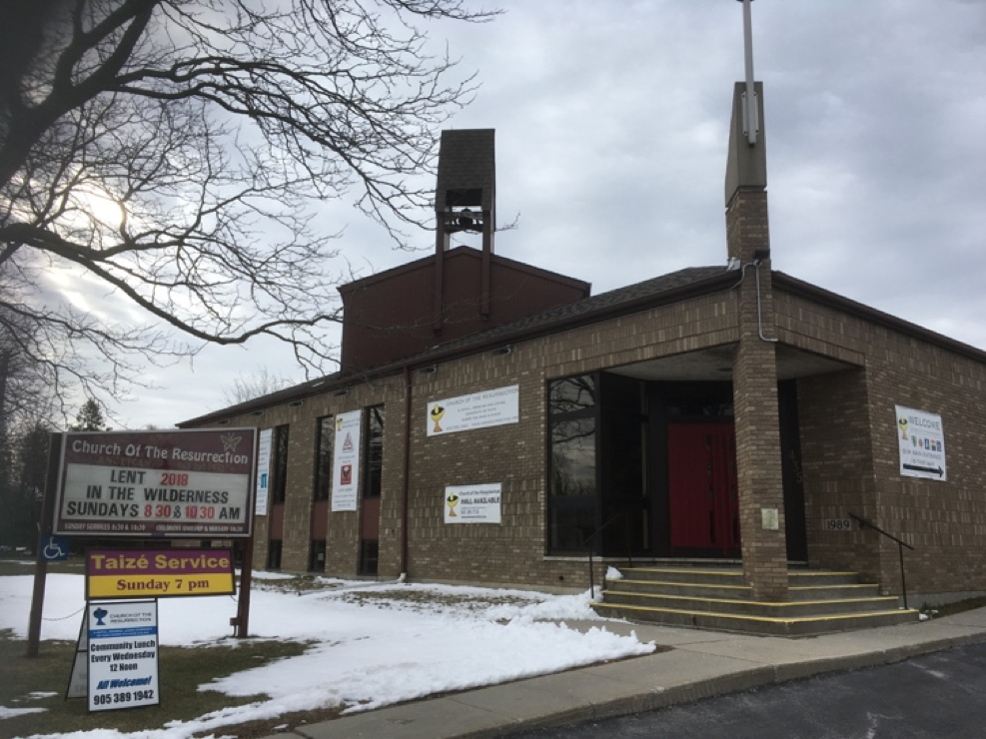

What is it?
- Front Entrance
- Washrooms
- Sacristy hallway to fire exit
How does it bless us and benefit the mission of the church?
- Mohawk Road access
- Planter is attractive
- Fire exit
- Gender neutral accessible washrooms with infant change tables.
- Storage space for Altar Guild
- Access for clergy from office to worship space.

What are its limitations or draw backs?
- Not accessible
- Far from parking lot
- Can’t leave doors open at height of summer or winter- looks unwelcoming.
- Railings not very usable.
- Waste of space
- Dark, too narrow.
- Poor lighting.
- Clergy washroom- functional? Necessary?
- Sacristy too small.

What could we do differently or better with this space / what improvements could we make?
- Better signage
- Replace front sign SCHEDULED FOR UPGRADE – FUNDS OBTAINED
- Washrooms need better ventilation.
- Storage for toilet paper and other supplies should be to hand.
- Remove front entrance and stairwell- repurpose space for more worship space or new nursery.
- Bump out south sanctuary wall into hall way.
- Move bathrooms to more central location.
- Knock through from Sacristy to washroom, create bigger space?
- Door openers
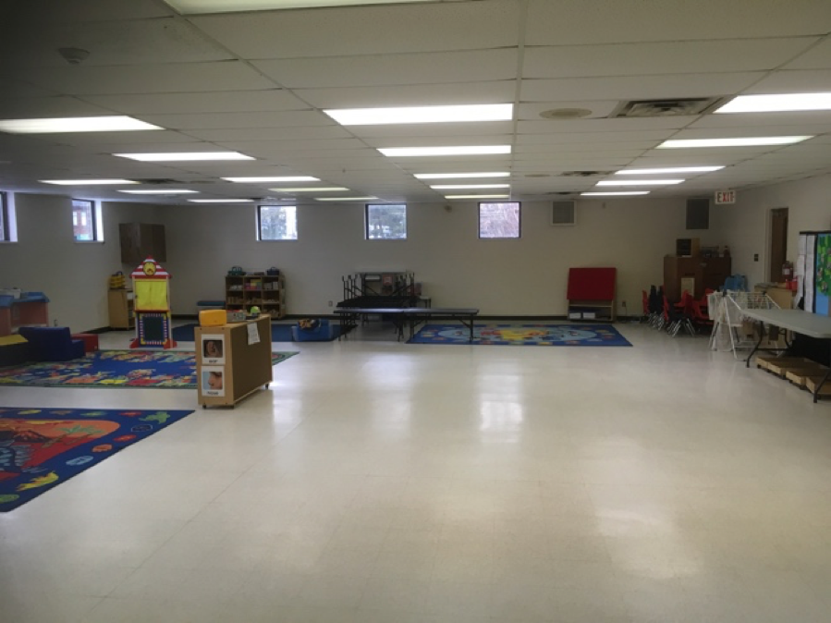
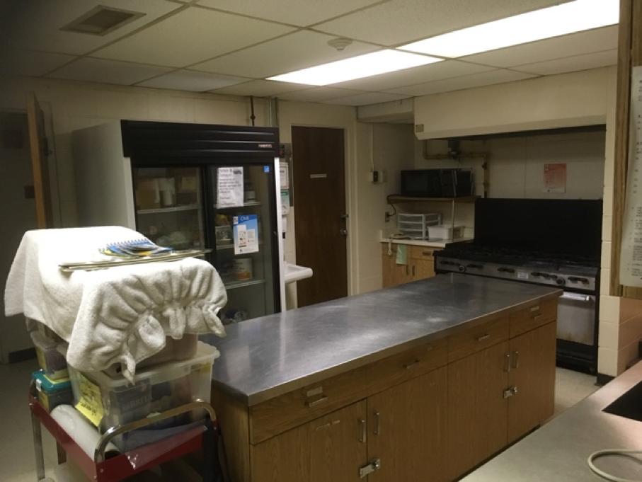

What is it?
- Mohawk Room and Lower Kitchen

How does it bless us and benefit the mission of the church?
- Catering for most community life events
- Catering for meat pies and other fundraisers
- Catering for funeral teas
- New fridge an asset to all.
- Catering community lunch.
- Catering for weekly community lunch.
- Party Room
- Main Rental space
- Large room for seated events.
- Mohawk Room has some natural light.
- Peter Pan Home (Pre-school)
- Multi purpose

What are its limitations or draw backs?
- Low ceiling
- Poor acoustics
- Looks cold and sterile
- Floor crappy
- Lack of storage for chairs and tables.
- Lighting inflexible and cold.
- Not available Mon-Fri daytime
- Kitchen far too small for our needs
- People do not feel empowered in kitchen.

What could we do differently or better with this space / what improvements could we make?
- Paint and decorate
- Create more storage
- New lighting.
- Storage for chairs and tables.
- Sound system could be installed.
- New ceiling, new floor
- Projector screen, AV capabilities.
- Higher ceilings?
- Expand kitchen.

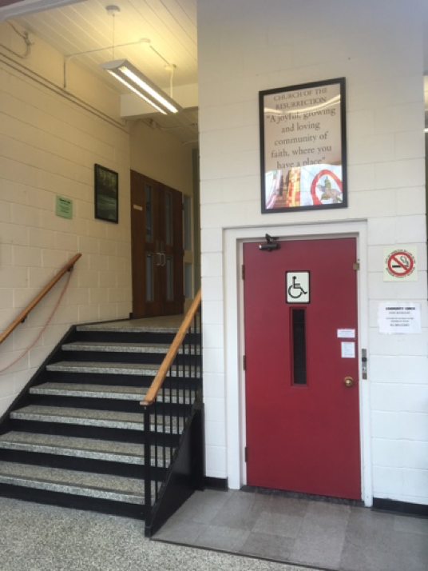
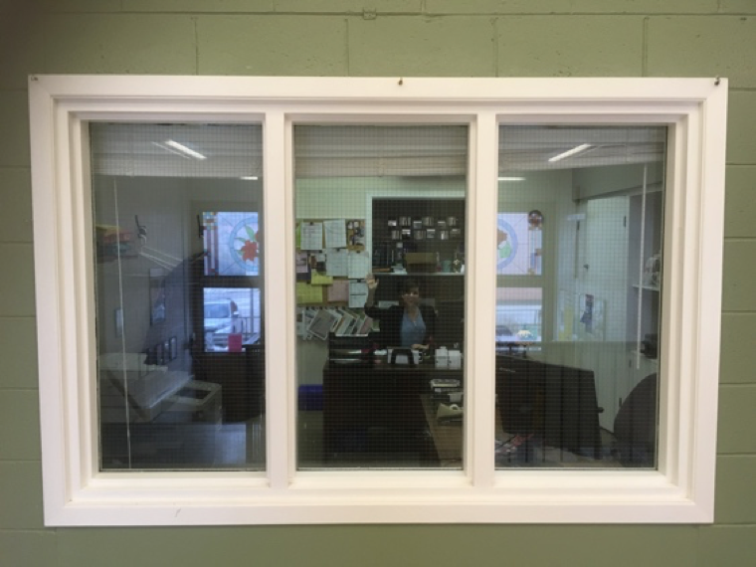
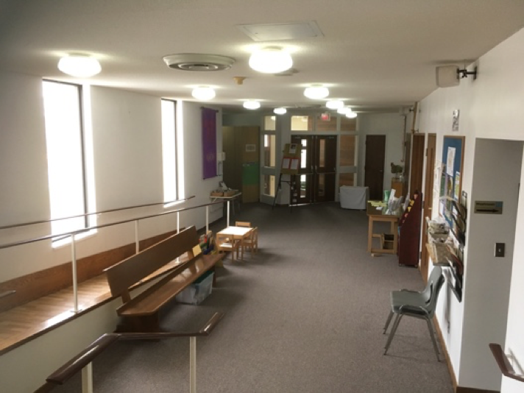
What is it?
- Side Entrance (Main Entrance) and Landing
- Main office and Narthex.

How does it bless us and benefit the mission of the church?
- Access to Elevator
- Access to church and offices
- Stairs between floors, access to basement.
- Main thoroughfare.
- Visible.
- Good lighting, eco-friendly.
- Whitened ceilings make for brighter entrance.

What are its limitations or draw backs?
- Need a person and key to bring the elevator.
- Floor gets messy in winter, hard to keep clean, slippery.
- Poor signage (where do I go when I enter your church?)
- Doors in poor repair.
- Narthex is cluttered and unwelcoming.

What could we do differently or better with this space / what improvements could we make?
- Door openers for accessibility.
- New signage.
- Changeable event signage? Digital screen?
- Remove sanctuary wall and front entrance wall, hallway wall to expand worship space.
- Remove blinds from office.- more inviting.
- Replace office window with floor-to-ceiling windows.
- Move elevator to another location- make accessibility part of the building.
- Cover over the cinderblocks.
- Warm up the colours of the paintwork.

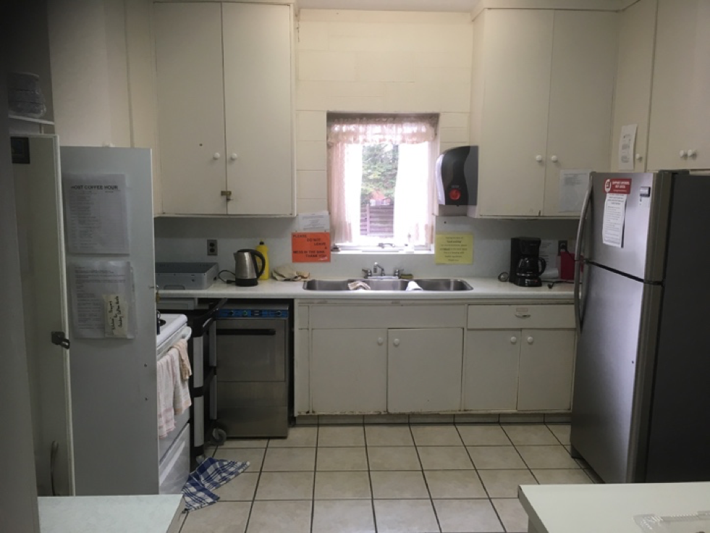
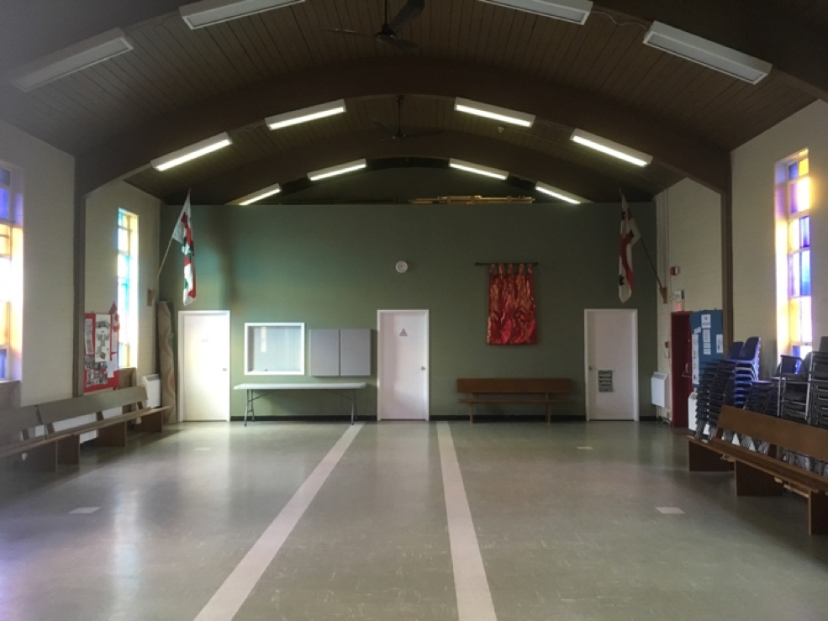
What is it?
- Canterbury Room, Canterbury Kitchen (original church with coffee hour facility)

How does it bless us and benefit the mission of the church?
- Gives us space for fellowship and coffee hour.
- Hall space for cubs, scouts, etc.
- Meeting space
- J.A.M. space for children’s work.
- Leon’s office.
- Access to loft storage
- Storage for scouts.
- Coffee hour.
- Event space.
- Hosts community lunch.
- Reception space.

What are its limitations or draw backs?
- Bad lighting
- Asbestos!
- Crappy windows-
- Heating (goes out through windows)
- No AC- sometimes too hot to be used.
- Needs a new oven.
- Kitchen too small- often over crowded- very limiting.
- Kitchen dated.
- Not welcoming
- Cluttered
- Too many pews
- Not ideal for Leon to have meetings.
- Poor cupboard space in kitchen.
- Poor acoustics.

What could we do differently or better with this space / what improvements could we make?
- New flooring DONE
- Remove asbestos REMOVED
- Build new kitchen / storage space along East side of Canterbury Room KITCHEN RENOVATED WITH NEW CUPBOARDS & COUNTERS
- New windows- clear glass for lighting.
- Hang Air con from ceiling.
- New lighting, brighter.
- Redesign the whole space/rebuild.
- Tidy / box in recycling area.
- Have an AV set up with screen and projector.
- Games equipment for youth?
- Demolish loft / office area. Put window in south wall to create larger space with natural light.

We also recognized that we had not discussed the need for better parking and the vital part played by our community garden and the hope we might have to expand that ministry in the future.

This discussion was a part of our ‘ten-year plan’- a process of discernment about the focus and energy of our ministry and the next steps to help us thrive. The building is a vital part of the longer-term conversation which holds up a lot of our ideas and plans. The current building is expensive to maintain and sucks our limited financial resources which could better be used for the practice of ministry.

Our discussion came to a few conclusions:
- The work and cost of making the current building viable is prohibitive and perhaps these resources would be better spent on a new building.
- A new building could be designed to better reflect who we are. It could be more versatile, smaller, significantly easier to maintain and clean and could play to our ministry strengths.
- This would make possible a move of our physical site to a growing area further south which we speculate is currently underserved.
- We cannot discern a way forward without being part of a larger conversation of the mountain ministry churches about the future of ministry and the sharing of resources.
- This would be a great conversation with which to engage and get to know our new Bishop.

We gave thanks to God that we were able to have such an open, frank, hopeful and joyful discussion about our ministry and its future.

PRIORITY 1: WORSHIP
Our vision for Worship at Resurrection:
Worship at Resurrection should be vital, inspiring, joyful, engaging, diverse and life-giving. It should build on our current momentum and evolve. We must draw on the rich tradition of Anglican Worship which we inherit.
FIRST STEPS 2018-2019
WHAT | WHO IS RESPONSIBLE
Create regular opportunity for Bible Study | Rector - DONE
Continue ‘Getting To Know’ with other topics. | Rector / Worship Planning
Increase the diversity of music | Rector, Choir, Music Director, musicians -DONE
Review recent changes and plan further worship space innovation. | Rector, parish council
Increase Lay volunteers involved in worship. | Rector
Try a ‘paperless’ season (N.B. see ‘Greening’ under Outreach and Justice) | Greening committee, Parish Office, Powerpoint coordinator
Sustain J.A.M (N.B. see Children and Youth Ministry) | Rector
Recruit a small team to plan one or more special services. | Rector
Create a ‘prayer-ground’ (N.B. See children and youth ministry) | Rector, parents, DONE
Encourage new forms of prayer during worship. | Worship planning
List ministry roles that require succession and begin succession planning. | Corporation and Parish Council
Maintain current variety- Taize, Carols, Holy Week, etc. | Rector /Staff
Second Steps 2020-2022
WHAT | WHO IS RESPONSIBLE
Explore a new form of worship outside of Sunday morning. | Rector
Create a liturgy and learning team to plan and implement at least one annual season of themed worship and education. | Rector
Create a new worship experience to increase variety and opportunities. | Rector
Seek opportunities to worship with and learn with other churches and christian groups. | Parish Council

PRIORITY 2:CHILDREN AND YOUTH
Our vision for Children and youth at Resurrection:
Children and youth ministry should be fun, energetic, well organized and resourced, nurturing faith and community among families and teens and fully including them in the life of the church.
FIRST STEPS 2018-2019
WHAT | WHO IS RESPONSIBLE
Ensure provision is made in budget for ministry. | Corporation
Keep Children’s Church and Sunday involvement consistent | Rector, Children’s coordinator
Sustain and develop J.A.M. | Rector
Showcase other resources | tbd
Invite Su McLeod to speak at Parish Council / Sunday a.m. (education!) | Rector (done March 2018)
Develop a sustainable plan for youth group | Volunteer leaders
Connect with and showcase Diocesan Youth Ministry | Mary Gordon
Find out what it would take for our church to be ready to hire a youth and children’s minister. | Corporation, Parish Council, Christyn P.
Create a more child friendly space (prayer-ground) within the worship space. | Rector (Done May 2018)
Recruit and train volunteers for active ministry with children and youth.

Second Steps 2020-2022
WHAT | WHO IS RESPONSIBLE
Begin active planning for Children and youth ministry staff position.
Seek local partnerships to participate in active support for local families.
Work with new teens to explore generational worship
Create intergenerational learning events.

Third Steps 2022 onwards
WHAT | WHO IS RESPONSIBLE
Hold visioning event for the next five years involving staff, children, families, youth and intergenerational support.

PRIORITY 3:INVITATION, WELCOME AND HOSPITALITY
Our vision for INVITATION, WELCOME And hospitality:
Church of the Resurrection must become more visible in the community and create a reputation for invitation and hospitality. This must become a whole church ministry so we are prepared to welcome newcomers into our relationships with understanding and sensitivity. Our welcomers will be well equipped for their ministry and the physical plant must mirror our commitment to welcome for all people.
First Steps 2020-2022
WHAT | WHO IS RESPONSIBLE
Create a welcome video showcasing our parish | Rector, Michael Wood
Create a welcome pack for newcomers | Rector, Parish Office
Hold a ‘welcome and orientation’ evening for newcomers. | Wardens, Welcome Team
Run training for greeters, include all parish leadership. | Rector / Honorary
Preach on welcome and hospitality. | Rector / Honorary
Assess ways our building can be made more inviting and welcoming and create an action plan to include signage, and accessibility etc. Declutter Narthex. | Dream Team / Parish Council
Prioritize ‘Back to Church Sunday’ or ‘Bring a guest to Church’ | Parish Council
Create visuals showing our leaders and who to approach. | Parish Office
Second Steps 2020-2022

PRIORITY 4: STEWARDSHIP
Our vision for STEWARDSHIP at Resurrection:
We will create a culture where gifts that are given and shared are recognized with thanksgiving and celebrated. Ways of offering time, talent and treasure and highlighting the needs of the parish will be shared and invited in new and creative ways. We will make it easy to get involved and easy to give.
FIRST STEPS 2018-2019
WHAT | WHO IS RESPONSIBLE
Gather a coordinating team for ongoing giving, fundraising and grant applications | Rector- in progress
Develop a Narrative Budget | Dream Team / Andrew Clinkard
Collectively theme our Stewardship campaign 2018 | Parish Council
Continue with town hall meetings and other regular updates. | Corporation ONGOING
Tell more stories of how volunteering makes a difference. | Rector, Parish Council
Create a new form of ‘ministry fair’. | Parish Council
Celebrate and pray for at least one ministry each year publicly in worship (servers, altar guild, choir etc). | Rector
Host volunteer appreciation again. | Rector
Invite guest speaker on stewardship | Rector
N.B. See also ‘Greening’ under ‘Outreach and Justice’

Second Steps 2020-2022
WHAT | WHO IS RESPONSIBLE

PRIORITY 5: COMMUNITY LIFE
Our vision for COMMUNITY LIFE at Resurrection:
As a sign of our joy in being a community in Christ, we will come together regularly to strengthen our connection with one another and to enjoy being together. We will ensure that community life events are diverse and everyone has opportunity to participate.
First Steps 2018-2019
WHAT | WHO IS RESPONSIBLE
Encourage the wearing of name tags at all events. | Welcomers, Office, Parish Council
Create a template and a resource box for running events that can be used to empower volunteers. | Parish Council
Lay out at least 4 diverse community life events for the year in the church calendar. Keep ticket price to minimum. | By invitation, brain storm by Parish Council
Brainstorm ideas for next year and find leaders to facilitate new events. | Parish Council

Second Steps 2020-2022

WHAT | WHO IS RESPONSIBLE
Explore the possibility of an all-age Resurrection retreat and / or pilgrimage. | RECTOR

PRIORITY 6: OUTREACH AND JUSTICE
Our vision for OUTREACH AND JUSTICE at Resurrection:
We will be a community that is aware of the needs of our local and global community and will find ways of putting our faith into action by participating in God’s justice making work in the world. This will involve education, prayer, generous giving, community partnerships and programs that actively meet needs.
First Steps 2018-2019
WHAT | WHO IS RESPONSIBLE
Appoint a Greening Coordinator and gather a committee | DONE
Begin work on Bronze Level Greening Niagara Standard | Greening Committee – IN PROGRESS
Support and sustain existing Justice Ministries | Parish Leadership

Second Steps 2020-2022
WHAT | WHO IS RESPONSIBLE
Review Justice Ministry and strengthen suite of programs.
Identify big-picture causes where Resurrection can make a difference and create an education and action plan.
Consider mission trip possibilities and build appropriate relationships.

PRIORITY 7: PASTORAL care
Our vision for Pastoral care at Resurrection:
Mutual care will be the responsibility of the laity and clergy together. We will build a culture where we are attentive to the pastoral needs of our neighbour and take active responsibility for communicating that care in safe, appropriate and helpful ways that mirror the love of God for God’s people. We seek to rejoice with those who rejoice and weep with those who weep.
First Steps 2018-2019
WHAT | WHO IS RESPONSIBLE
Encourage and educate people about mutual care. | Clergy, Parish Leaders
Continue with existing ministries: prayer cards, flower ministry, visits, home communions, nursing and retirement home Eucharists, prayer ministry etc. | Clergy
Review and renew our ministry of weddings and funerals. | Clergy
Continue prayer shawl ministry | Prayer Shawl Team
Second Steps 2020-2022
WHAT | WHO IS RESPONSIBLE
Recruit a ‘Pastoral Care team’ and provide training. Create a structure for supervision. | Rector with external support
Invite a guest speaker to Parish Leadership Vision Day and Sunday morning worship. | Rector
Train prayer teams to offer Sunday prayer ministry.
Create a pastoral response team to cook meals and offer other practical help.
Re-establish pastoral prayer chain.
Offer ‘A Good Death’ workshops.

Third Steps 2022 onwards
WHAT | WHO IS RESPONSIBLE
Create a Pastoral Coordinating Group to promote, oversee and develop Pastoral care initiatives throughout the parish. | Rector to recruit from volunteers with appropriate skill set.

