PARISH
PROFILE

Church of the Resurrection Hamilton, Ontario

435 Mohawk Road, West
Hamilton, On L9C 1X1

Telephone: (905) 389 – 1942
Fax: (905) 389 – 1566
Email: oneresurrection@rogers.com
Website: www.angmtnparishes.on.ca
Contents
1. Location and Membership 3
2. Worship 6
3. Organizational Structure 10
4. Programmes and Organizations 11
5. Finances 16
6. Property 17
7. Diversity and Inclusivity 18
8. Wider Church 19
9. Wider Community Involvement 20
10. Situational Analysis 20
Vestry Reports 21
Parish Questionnaire Results 21

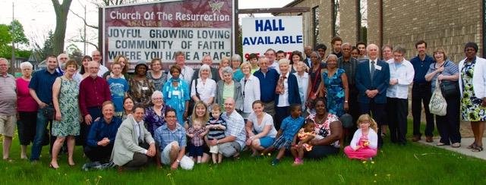
“A joyful, growing and loving community of faith,
where you have a place”

1. Location and Membership

“Let your light shine before others, so that they may see your good works and give glory to your Father in heaven.” (Matthew 5: 14-16)
Our Community
Hamilton is a mid-size city of approximately 537,000 people in the central core. In 2001, several smaller towns were amalgamated into the new City of Hamilton, and the resulting metropolitan area has a population of over 747,000 – the third-largest metropolitan area in Ontario and the ninth-largest in Canada. It should be noted that Hamilton is a demographically aging community. The largest employment sector has changed over the years from steelmaking to health services. Hamilton is also home to McMaster University (and their Divinity College), Redeemer University College and Mohawk College.
Almost a quarter of Hamilton’s population is formed of permanent residents or naturalized citizens, and the number of newcomers settling in Canada each year has been steadily growing over the past few decades.
Hamilton manages to combine a small-town feel with a metropolitan infrastructure, so while it may seem like a big bustling city, locals living in Hamilton can be disarmingly friendly. Every store clerk and restaurant server will greet you like a long-lost friend. It might seem awkward at first, but you’ll soon get used to it.
Many Hamiltonians have lived in the area their whole lives and remember a time when the city experienced rapid economic decline and job losses. The recent regeneration of the city is in large part a result of local communities making changes at a grassroots level, and people are passionate about their city in a way that isn’t as common in bigger, more populous cities.
Hamilton has recently begun to attract a growing crowd of young people and creative professionals. As this community grows, so does the range of restaurants, stores, and creative pursuits available. From themed bars to specialty restaurants, niche artisan stores and collectives, Hamilton is becoming an impressive creative hub in southern Ontario.
Hamilton is Ontario’s fifth most-populous city, but it ranks 27th for population density. This means that there is plenty of space for everybody. Properties can be large, with plenty of garden space, and a large share of the population lives in dispersed suburbs around the downtown core. If you are looking to make a home in a spacious suburb with lots of room for kids and pets, living in Hamilton could fulfill that vision while providing vibrant and convenient amenities.
The Hamilton Mountain
The Hamilton "Mountain" is an area that is situated atop the Niagara Escarpment which cuts through the middle of the city separating the upper southern and lower northern portions of the city. Hamilton Mountain is blessed with many parks, playgrounds and green spaces. Of course, we cannot fail to acknowledge Hamilton as the City of Waterfalls. Most of them are a consequence of the existence of the Niagara Escarpment. Waterfalls not only play a significant role in our history but they also add to our scenic beauty in dramatic and spectacular ways. The Mountain has walking and hiking trails and some fascinating natural areas that have only recently come to public attention.
Our Neighbourhood
We are located in the West Hamilton Mountain area which is bordered by Garth Street on the west and Upper James Street on the east, with the Niagara Escarpment serving as its northern border, and the Lincoln Alexander Expressway (the Linc) as its southern border. This area incorporates the Mohawk, Buchanan, Rolston, Southam, Bonnington, and Yeoville neighbourhoods. Resurrection is located in the Rolston neighbourhood, which is bordered by Garth St, Mohawk Rd W, West 5th St and the Linc.
While the majority of the west mountain neighbourhood area is residential, the area also offers close and convenient access to a selection of grocery stores, shops, restaurants and shopping plazas along Upper James Street on its eastern border. The area also hosts both Mohawk College and Hillfield-Strathallan College, as well as a number of Public and Catholic Schools, library, day care centres and a variety of churches.
Currently our parish ministers to two neighbourhoods: Rolston and Buchanan Park.
The Buchanan Park neighbourhood is a blend of single-family homes (owned) in addition to many rental units to accommodate the students who attend Mohawk College. This area is more affluent in many ways compared to Rolston. It is not uncommon to see young families utilizing this area’s public parks, local schools (including a French-speaking school), while also gathering at the playground and splash pad that are part of the park. Buchanan is a very active community.
In contrast, Rolston is a neighbourhood that is also serviced by our church community, however there is more poverty present in some families or individuals including seniors. It is not uncommon to find new immigrants in this area in addition to geared-to-income housing. There is also a larger population of children under 6 years of age in this area along with lower rates of education compared with the city at large.

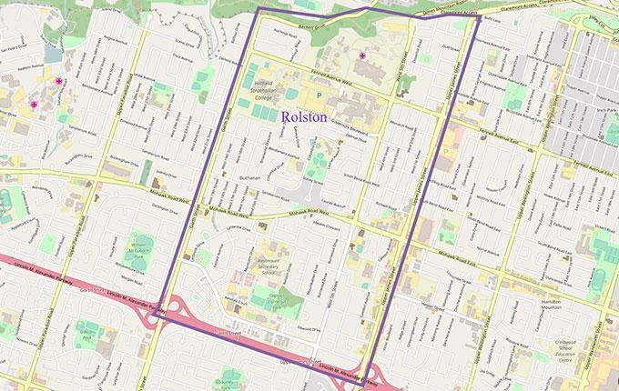

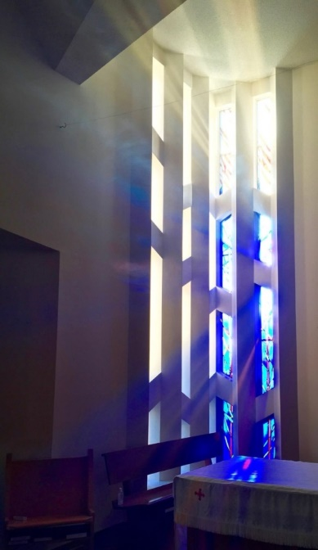
2. Worship

“Let the word of Christ dwell in you richly; teach and admonish one another in all wisdom; and with gratitude in your hearts sing psalms, hymns, and spiritual songs to God.” (Colossians 3: 16)

Church of the Resurrection is a community whose ministry is shaped by and rooted in meaningful and life-changing worship. We are empowered by strong preaching, a commitment to prayer, celebrating God’s presence in breaking bread, being gathered as a diverse community, and then being sent out as a renewed people to be the body of Christ at work in the world together. We offer a variety of worship services that seek to nurture faith, embolden our vision, and provide the spiritual tools to participate in God’s mission in becoming followers of Jesus.

Sunday Liturgies
8:30am | A said Holy Eucharist about 45 minutes long with most of the liturgy coming from the Book of Alternative Services. | 23 people in attendance on average
10:30am | A contemporary Holy Eucharist with liturgies derived from a variety of sources.  The liturgy is presented via an audio/visual system as well as a hard copy bulletin. It is about 1 hour in length. Music is led by our parish choir with various instruments under the direction of our music director. We have the opportunity for the laying on of hands/healing prayer offered during communion in our chapel space. Children’s Church takes place during the sermon/prayers of the people time. Our children’s corner is a space often occupied by children during the other parts of the service. Coffee Hour follows this service in our parish hall. | 99 people in attendance on average

There is currently no midweek worship service.
SPECIAL SERVICES
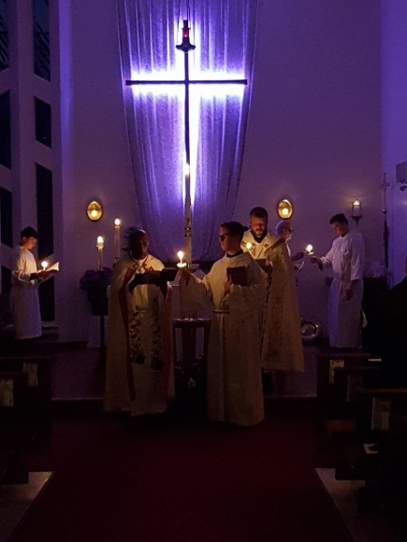
Church of the Resurrection is nourished by the rhythm of the Liturgical Year, including observing special feast days.
Christmas time- Resurrection offers four services: on Christmas Eve, a 4pm children and family Eucharist, at 7pm a Choral Eucharist and at 11pm a Choral Eucharist with incense. On Christmas morning, a Holy Eucharist at 9am is offered. Christmas attendance in 2018 was 225.
Lent and Holy Week- Resurrection puts particular emphasis on the journey of Lent, Holy Week and Easter. On Ash Wednesday, a said service is held at 10am and a Choral Eucharist at 7pm. In the past, worship during Lent has taken on a theme, and sometimes included a sermon series. This provided the opportunity for catechesis. Daily worship opportunities have been offered during Holy Week. Easter attendance in 2018 was 196.

Church of the Resurrection also holds special worship services throughout the year, including things like:
- The International Day Against Homophobia, Biphobia and Transphobia (May 17th) Holy Eucharist. We have been privileged to have speakers and celebrants from various walks of life, who are members of the LGBTQIA2S+ communities. This service has drawn participation from across Hamilton.
- Community Christmas Carol Service (an evening on third Sunday of Advent), held annually since December 2014. This was instituted it as a pre-Christmas gift to members of the community and reaching out to those who are perhaps new to Church. This informal service will oftentimes have a theme, and include a mix of worship, prayer, reflection and humour. Christmas readings are drawn from both scripture and secular sources. This service calls upon the talents of musicians and a diverse group of readers to present a reflection on the Christmas story.
Other Liturgical Expressions
Nursing Homes- Worship services are offered at Deerview Retirement Residence and Idlewyld Manor (nursing home) twice per month. They are currently led by our Associate Priest and a team of lay volunteers.
Taize- on the second Sunday of the month at 7pm, Taize worship is offered in the church chancel. Candlelight, chants, readings, a reflection, prayers, and the laying on of hands with healing prayers all accompany this beautiful service from the Taize Community ecumenical monastic order. 16 people in attendance on average.
Jesus and Me (J.A.M.)- On the second Thursday of the month after school at 5:30pm, children and their families come gather for a pizza dinner, followed by a bible story, songs, crafts/activities, re-connecting with friends and taking home a message about Jesus.
Involvement in Worship
One of the cherished strengths of Church of the Resurrection is the high level of lay involvement in planning and leading worship.
Planning:
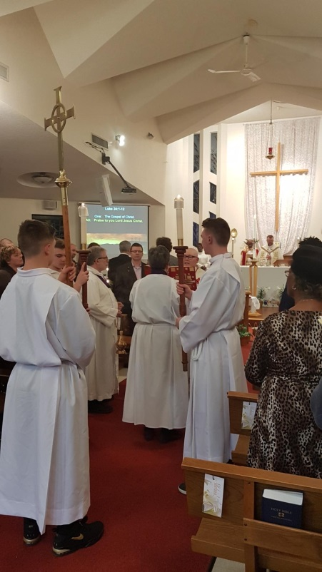
Planning worship occurs under the authority of the Rector. Once the liturgy is planned, the Rector along with a team of clergy will delegate responsibilities in worship through the readers, servers, Eucharistic assistants and prayers of the people rota. There is a team consisting of the Rector, Music Director and Assistant Musician that plans the music for worship for each season.
Leading:
Resurrection is blessed to have many clergy and lay leaders involved in the leadership of worship. We have a diverse preaching rota including 3 honorary clergy and 7 licensed lay readers, in addition to the Rector and Associate Priest. Lay Readers regularly take part in the service as preachers, readers, prayer leaders, distributers of bread, and Eucharistic assistants. The diversity of our worship leadership is also reflected by the large number of people who read the scriptures, lead the prayers of the people, act as Eucharistic assistants, and serve at the altar during our worship services.
Here are the number of lay leaders in ministry areas pertaining to worship:
Servers | 6 active
Readers | 20
Intercessors | 7
Eucharistic Assistants | 15
Greeters/Sides People | 31 + 3 alternates
Altar Guild | 16
Choir | 19

Many of our lay leaders are active in more than one area of ministry for worship. Training occurs for these worship leading areas about once every other year.
Reviewing:
Church of the Resurrection often reviews worship informally, receiving feedback from the congregation and leaders when new or creative approaches are tried. In 2017, a sermon series called ‘Getting to Know’ (revisiting the basics of faith) was reviewed by the parish at large through a survey. This sermon series lasted 3 months and was accompanied by a furniture change. This was also reviewed in a survey by the parish at large.
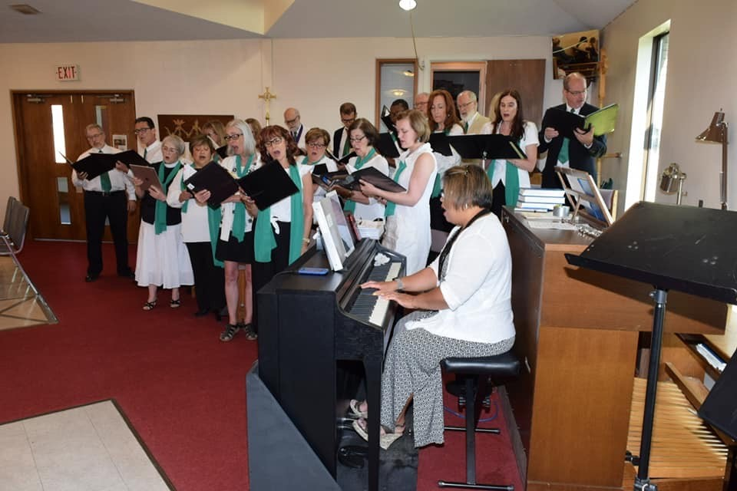
Music
Church of the Resurrection enjoys a diverse range of music, particularly for the 10:30am Sunday morning Eucharist. Music is overseen by the Rector, the Director of Music and with the help of the Assistant Musician. This service music is led by our 19 voice SATB choir accompanied by the piano and occasionally organ as well as other instruments, offered by musically gifted members of our choir. Music at Resurrection includes hymns, choir anthems, solos and instrumentals. Our enthusiastic Director of Music is always looking for ways to challenge and grow the choir, both musically and spiritually.
About 60% of our hymns come from the Canadian Anglican Hymn Book, Common Praise. The other 40% come from a variety of sources such as Breaking Bread, More Voices, the Iona Community, etc.
Statistics for 2018
 | Baptisms | Confirmations | Weddings | Funerals
2018 | 3 | 0 | 2 | 9
2017 | 4 | 2 | 3 | 7

3. Organizational Structure

“Now there are varieties of gifts, but the same Spirit; and there are varieties of services, but the same Lord” (1 Corinthians 12: 4-5)
The Parish operates with an incumbent priest, one non-stipendiary associate priest and 3 honorary assistants. We are blessed to be assisted by 7 licensed lay readers. The office is managed by a part-time Parish Administrator and a part-time Rental Event Coordinator.
Resurrection operates with a full slate of Wardens and Deputy Wardens.
Rector’s Warden – 2 year term
Deputy Rector’s Warden – 2 year term, then assumes Rector’s Warden role.
People’s Warden – 1 year term
Deputy People’s Warden – 1 year term, then assumes People's Warden role.
Corporation meetings as usually held once a month. Corporation meetings include Wardens and Deputy Wardens, who work collaboratively as a team to address the business of the parish.
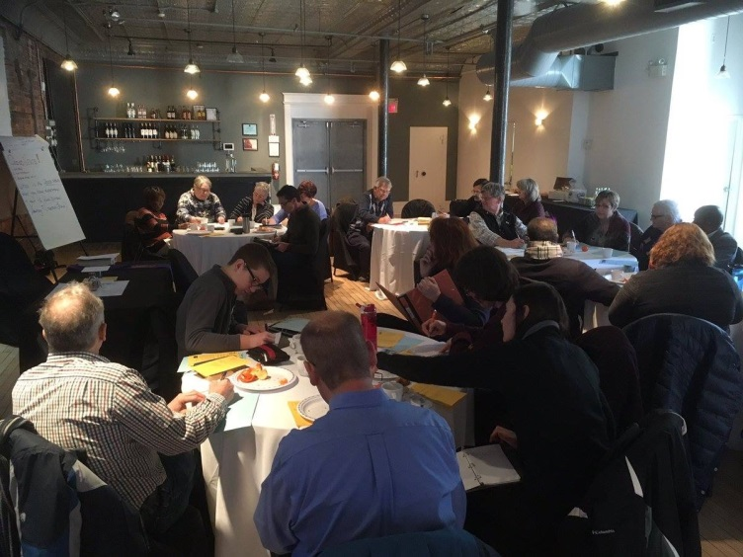
Parish Council, consisting of the Corporation, Treasurer, Delegates to Synod and Alternates, and many members at large meet on average every 6 weeks. They are responsible for reviewing parish business and finances, and providing direction regarding the programs and initiatives undertaken by the parish. The Parish Council has developed a 10-year plan for the parish. At present, there are no standing committees.
At COTR, we take volunteer screening seriously. Everyone who volunteers for a position in the church is screened as per diocesan requirements. Those in positions of authority over others are required to provide Police Record Check and Vulnerable Sector Screening. All volunteers are provided with position descriptions for their role. All records are managed by the Parish Administrator.

4. Programmes and Organizations

“For I was hungry and you gave me food, I was thirsty and you gave me something to drink, I was a stranger and you welcomed me, I was naked and you gave me clothing, I was sick and you took care of me, I was in prison and you visited me.” (Matthew 25: 35-36)

As a Resurrection People we have a vibrant group of ministries to nurture and grow all people from children to seniors and everyone in between.
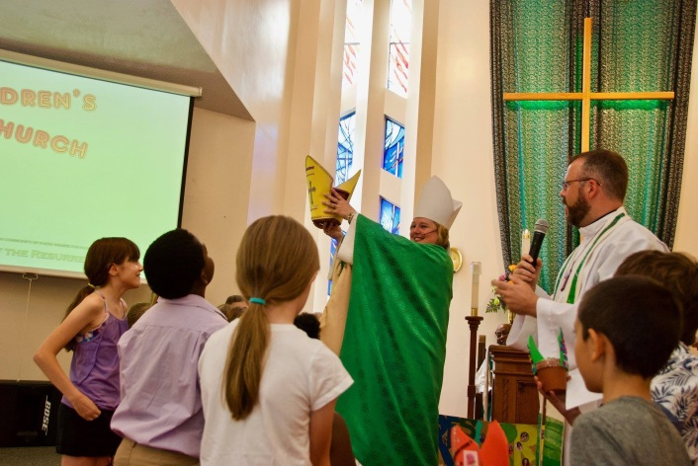
Children: Every Sunday at the 10:30am service a group between 2 – 12 children have a special time together where they read the lesson and have a craft/or game to bring the day’s reading alive and practical to practice at home, school and play. For those remaining in the service a special children’s area has been created where activity sheets and books are available. The greater community is invited once a month to an afterschool program, JAM (Jesus and me) where they share a lesson, sing, pray, play, craft and pizza. In addition we run a very successful “Breakfast with Santa” that attracts a full house of Peter Pan daycare patrons, local community members and parishioner families.
Youth: Meet monthly to share thought provoking worship, good discussion, great fun and great treats. They have gone to Diocesan Youth events, 541 Eatery and Exchange breakfast, 2 day retreat, and Mancala Monk Board Game Café. The Resurrection family has made Youth Ministry a priority and have begun a Youth Fund to grow and sustain our youth/future of the church. Generally, the children graduate to youth involvement in the church through serving, prayers of the people, readers and audiovisual service team. Resurrection youth actively participate in diocesan youth programs. We have continually had 2 synod youth delegates participating at synod and on parish council. We seek to support our youth and incorporate them in all aspects of life at the Resurrection.
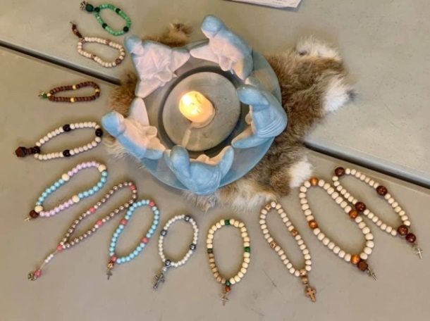
Adult Faith Nurturing: A growing number of parishioners actively participate in weekly Bible Study sharing the contextual content and practical application in our lives. Revive we have 24 participants signed up to enrich and empower individual and corporate faith journeys. The book club meets monthly, studying a variety of authors and subjects.
Prayer Ministry: Electronically we have an active prayer blog as well as a physical prayer board where parishioners are encouraged to add prayer requests. To support the community a monthly Taizé service allows for contemplative prayer, encouragement and spiritual refreshment. In addition, we have a diverse lay team who lead the weekly prayers of the people. During this time, it is our practice to open the prayers to the community to add their petitions and thanksgivings.
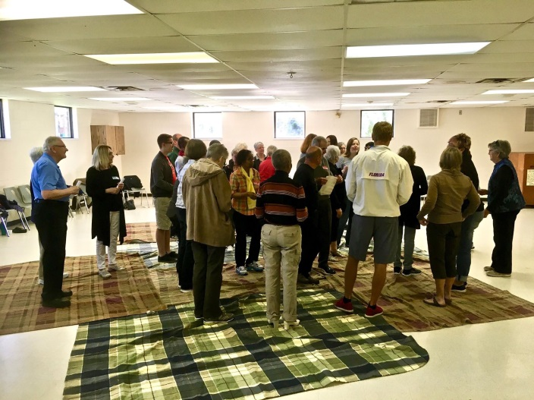
Community Engagement, Outreach, and Advocacy: Vitally important to the Resurrection are social justice and outreach initiatives. We take seriously our role as a loving community of faith in Hamilton. Throughout the week you will see parishioners and community members involved in our Victory Gardens, community lunch, women’s spaces, and the refugee sewing group. During February we host “Living Black History” where our strong Black communities lead exciting education programs (music, lectures, discussion, displays and food). Annually we host Eucharist International Day Against Homophobia Service. The social justice cluster lead our green church initiatives, out of the cold program participation, Aboriginal Reconciliation/Education events, and Black History Month events.
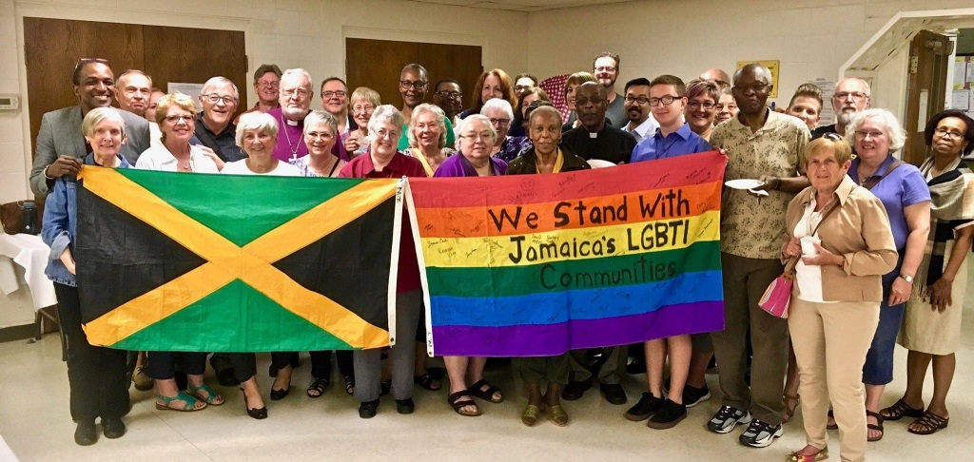
Periodically throughout the year Resurrection participates in Mountain ministry cluster for social events, services and educational nights (Good Friday celebrations, picnics, anniversaries, LGBTQIA unions talk, and other church celebrations).
Wednesday Community Lunch – Initially, the lunch was launched as a Senior’s Social group offering light refreshments, cards, jigsaw puzzles, and other games plus conversation to help alleviate the high rate of isolation of seniors as noted from Social Planning and Research Council, SPRC, studies of Rolston neighbourhood. Although we offered ‘The Canterbury Connection’ program for one year to fulfill the terms of a New Horizon’s for Seniors Grant, we realized the program was not growing. The lunch program began in 2015 with seniors in mind initially but we were not able to attract as many people as we knew were out there so we opened the lunch up to the entire community, not just Rolston, and to all age groups. It’s been steadily growing ever since, with attendance growing from 20 meals served per week to over 50+ consistently since September this year.

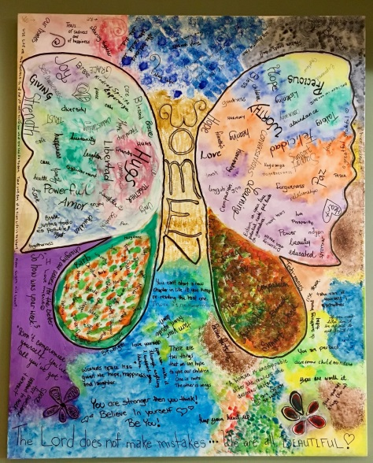
Women’s Space Group – (in partnership with the Neighbour to Neighbour (N2N) Good Group) – The group was formed through a partnership to continue a women’s group every Thursday morning. It was originally a N2N program with a paid group facilitator. We managed to receive a small grant from the Diocese to employ a facilitator for an extended short time, but no longer have the funds to pay anyone. We carry on by sharing the load. N2N continues to supply bus tickets for those needing them; ongoing support arranging guest speakers and resources as available, and ongoing promotion of the program. Our parish and N2N have a very co-operative ongoing relationship. We in turn support them with weekly food donations and produce from our gardens when in season. We offer light refreshments, lively conversation, shared life experiences and additional support if possible through contacts or services or just listening to each other. The volunteers and guests look forward to being together every Thursday morning and are always open to newcomers – women only!
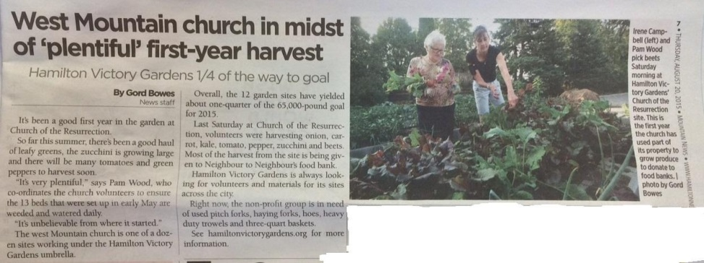
Victory Gardens – Entered into a partnership with Hamilton Victory Gardens in the spring of 2015. 13 raised beds were built and have since been planted, maintained and harvested by COTR and community volunteers from April – September/October growing fresh vegetables for local food banks, mainly Neighbour to Neighbour.
Refugee Sewing Group – The sewing program is entering its third year with the Boys and Girls Club (formerly HARRRP). Starting as a drop-in sewing class where newcomers to Canada would learn to sew and have an opportunity to socialize. This year we offer a 10 week beginner sewing program to build their confidence using a sewing machine, learn basic sewing techniques, practice English and make friends (projects include: tote bag, pillowcase, apron, and dress).
Visitation: Visitation needs are mostly met by clergy, however we have an “Inreach to Parishioners Group” who send birthday, missing you, get well and condolence cards to parishioners. The Flower Ministry group deliver the church flowers to shut-ins and parishioners experiencing difficult times. The Prayer Shawl Ministry group prayerfully create shawls and lap blankets. Once or twice a year all the creations are blessed. The clergy deliver them to those in need. We have received many thank you cards stating how much these shawls meant to those in hospital or at home convalescing. Clergy offer Eucharist and prayers to residents at Idlewyld Long Term Care Home and Chartwell Deerview Retirement Residence and lead biweekly services at Idlewyld (where both lay and clergy assist in delivering a joyful service).
Worship Groups: The Altar Guild work closely with the clergy to set up the altar, hanging candles and decorating to enhance the worship services. The choir, audio visual team, readers, chalice bearers, prayers of the people team, greeters, presenters, sides people and altar guild actively participate in the weekly and high holiday services to enhance and enliven the liturgy to meet a diverse community. Our Parish Council actively participate in leadership roles in fundraising, ministry leadership and visioning.
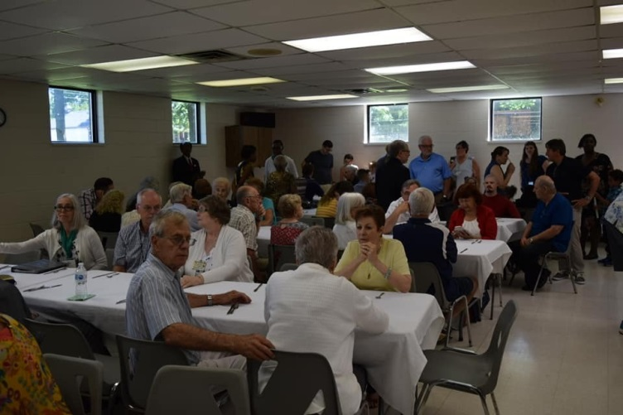
Other Groups: The Building & Maintenance (Tim’s Team) meet weekly to keep our building and grounds looking great, functioning and well maintained. Garden’s group maintain the flower beds on our property to make Resurrection look inviting for the community to come in and enjoy our many programs. Tri-annual Deep Clean Parish Team join together on one Saturday in May, Sept., and Jan. to pull on the rubber gloves and clean inside and outside of our building to be ready to serve and invite the greater community. The Men’s Group (currently on hiatus) meets periodically for bible study, breakfast, scotch tasting, beer/or wine making and occasionally helping organizations with small building maintenance projects (i.e. HARRRP washroom).
Community Life: Hospitality is our name and we have many groups that keep us fed and happy. The Coffee Hour Hospitality Group ensure we have coffee and goodies to share during after service fellowship time. A time to catch up on what is happening and meet new people. The Community Life Group, our famous kitchen gang, meat pie makers and catering group lead our many fundraising and social events (Pancake Tuesday, Breakfast with Santa, Christmas Carol Service, Easter Vigil wine and cheese, high tea fashion show, goodies to follow special concerts/speaker events, Christmas Market bake sale, and sales of prepared foods (Meat Pie, French Canadian Tourtieres, Quiche and Shepherd’s Pies). The team also does an amazing job catering funerals and memorials. Catering and serving the greater community during families most difficult times. The Black History Month team plans and delivers annually a month-long educational program with speakers, films, choirs, food and discussion. The Dream Team, is a dedicated group that brainstorm and lead fundraiser events (Silent auctions, guest bands and/or choir, Black History events, High Tea Fashion Show, Barrel of Beer raffle, Cocktails & Canvas, our choir, and a Cooler of Wine). Finally, our Volunteer Appreciation night put on by clergy and staff to show their appreciation for everyone’s many hours of service in God’s Loving Ministries everyone contributes at Resurrection.
Greater Community Groups: As part of our family we are home to many groups and services (everyday our doors are open to the community):
 | Community |  |  |  |  | Church groups
Monday | Peter Pan Co-Op Preschool | 97th Hamilton Scouting groups | A/A Friendly Persuasion |  |  | Tim’s Team  Refugee Sewing Group  Parish Council
Tuesday |  |  | Early Words
Wednesday |  |  | TOPS |  | Hamilton Quilter Guild, 2nd Wednesday | Bible Study  Community Lunch  Revive  Prayer Shawl, monthly
Thursday |  |  | Early Words |  | Hamilton Aquarium Society, 2nd Thursday | Women’s Spaces  Choir  Hospitality Group, monthly
Friday |  |  | Al-Anon
Saturday
Sunday | Hamilton Charity Auction, monthly |  |  |  |  | Revive  Taize
Occasional users | Jamaica Foundation | Barbados Association | Condominium corporation | Niagara- Huron Cursillo

Children Challenges:
- offering a one room program for ages 3-12 year old’s (very wide range of capabilities, and interests)
- developing a simple curriculum for the very short duration of 20 minutes
- a fluctuating number of children week to week (2-12 children)
- recruiting volunteer teachers and helpers to provide an exciting educational program
- a growing pre-teens group is feeling left out or in-between programs. Many have grown up at the Resurrection and feel too old of Church School and not ready for the high school group of youth.

5. Finances

“For where your treasure is, there your heart will be also” (Matthew 6: 21)
Our on-going monthly expenses for 2019 are up to date including Diocesan Mission & Ministry (DM&M) assessment. Sometimes we scramble to meet our year-end budget but the parishioners have never failed to help us meet the year-end deadline. The Parish has not experienced an annual deficit in over 20 years.
We have approximately 80 parishioners on Pre-Authorized Payment. Presently this amounts to $8,500 per month.
We have one outstanding debt with the Diocese, having borrowed from our rectory fund for various reasons over the years. The debt is now approximately $60,500, and the parish makes a yearly payment of $3,600 towards paying it off. The rectory fund presently totals $71,500.
We have an investment totalling $20,336, which the credit union will draw on if we go into overdraft, and an endowment (memorial) account of $5,247.
More details can be found in the financial statements in the Vestry minutes attached in the Appendix.

6. Property

“Then Jacob woke from his sleep and said, “Surely the Lord is in this place—and I did not know it!” And he was afraid, and said, “How awesome is this place! This is none other than the house of God, and this is the gate of heaven” (Genesis 28: 16-17)
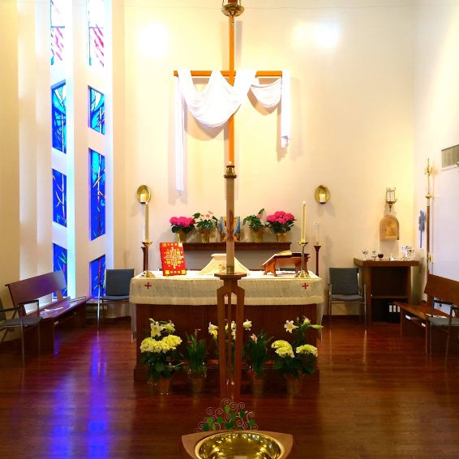
Our building is one of our primary resources for our mission as a church and its ongoing care and upkeep are a significant challenge. The church building consists of an original 7425 sq. ft. building constructed in 1960, with an addition in 1989. The original building contains offices, a hall (the Canterbury Room), kitchenette, and storage on the upper floor and the Fireside Room, youth group room, Niagara Room, nursery, maintenance boiler room and storage on the lower level. The two-story addition contains the current sanctuary, nave, narthex and gender-neutral washrooms on the upper floor. A large hall (the Mohawk Room) and large kitchen, custodian room, elevator maintenance room, and washrooms on the lower floor.
All areas of the building are handicap accessible via an elevator and ramps. Wireless internet is available throughout the building.
The upper story of the addition (nave, sanctuary, narthex, sacristy and washrooms) is air-conditioned and heated via an air handling unit located in the furnace room. The original building is not air-conditioned, and heat is provided via a hot water boiler and radiators.
The flooring in the Canterbury room, kitchenette and the upper hallway was replaced this year with LVP flooring. The kitchenette was renovated this year.
A Decennial inspection of the church building and grounds was carried out in June 2014 and at that time the building was found to be well maintained and the majority of the systems were found to be in good repair. The report recommended many items that should be looked at.
Things that may soon need attention:
- The flooring in the lower level of addition needs replacement.
- The eaves on original building needs painting.
- The side entrance way window seals.
- Storm windows in the original building needs upgrading.
- Roof on original building replacement. (Still no leaks)
- Parish Administration Office needs flooring upgrade.
There is a large paved parking lot behind the church. It was resurfaced and painted in 2018
A detached single car garage is located on the east side of the original building and serves as a storage for the lawn tractor and other maintenance equipment, as well as some camping equipment for the scouting group we sponsor.
In the southeast of the property there exists a pioneer cemetery dating back to the 1700’s. Through some great research it was discovered that a War of 1812 veteran who served in the 5th Regiment Lincoln Militia during the War of 1812, Private Jacob Hess, is buried there. A memorial dedication took place in October 2019.

7. Diversity and Inclusivity

“There is no longer Jew or Greek, there is no longer slave or free, there is no longer male and female; for all of you are one in Christ Jesus” (Galatians 3: 28)

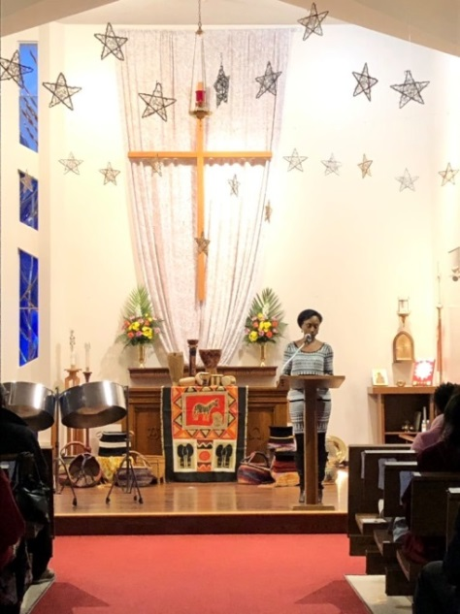
The face of Hamilton is changing and it is only fitting that the Anglican Church will experience that change. Statistics Canada new data from the 2016 census says that Hamilton’s visible minorities have more than doubled in the last 20 years. The visible minority population now sits at 19%. The Church of the Resurrection is proud that our congregation reflects that percentage.

The Church celebrates Black History. We have a Living Black History Committee which organizes events like movie nights, guest speakers and discussions during the month of February. They are presently setting up a Living Black History Library.

The Barbados Canadian and Friends Association have been celebrating Barbados Independence here at the Church since 1978. Once a year (usually on the Feast of Christ the King) the Association joins us for a Barbados Sunday celebration, including hosting the coffee hour with music and Bajan treats.

The Jamaica foundation regularly use our building for meetings and social time.

The Church of The Resurrection places an intentional emphasis on being an inclusive church which does not discriminate on grounds of economic power, gender, mental health, physical ability, race or sexuality. We believe in a Church which welcomes and serves all people in the name of Jesus Christ.

The Church Of The Resurrection acknowledges that the land on which we gather is the traditional territory of the Haudenosaunee and Anishinaabe. We seek a new relationship with the original peoples of this land based on honour and deep respect.
Our parish has taken initiatives to further our knowledge and awareness of aboriginal history and experience. This includes reading the Lenten study book “The Reason You Walk” by Wab Kinew, hosting a Blanket Exercise in May 2017 and arranging a speaker from the Mohawk Residential School at a Sunday service in May, 2017. This was followed by a visit to the Mohawk Institute Residential School and Museum in Brantford in September, 2017. We will hope for opportunities to further our knowledge of the journey including the involvement and experience with the Anglican Church of Canada.

8. Wider Church

“But you will receive power when the Holy Spirit has come upon you; and you will be my witnesses in Jerusalem, in all Judea and Samaria, and to the ends of the earth.” (Acts 1: 8)
The Church of the Resurrection is engaged in ministry with the wider church in a number of ways:
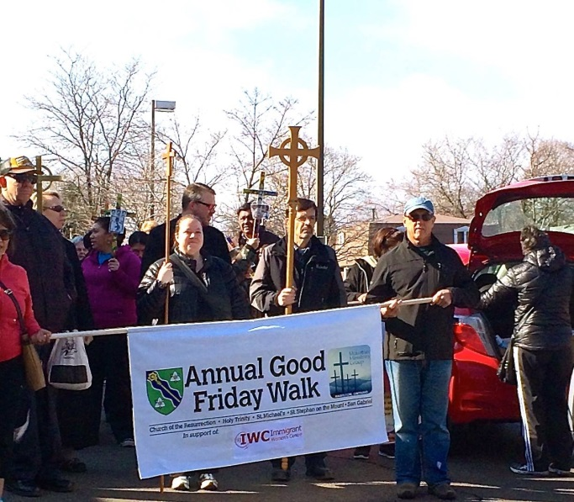
- There is a healthy understanding in the congregation that we are a parish within a Diocesan structure—we fully participate in Synod meetings, regional gatherings, and keep our DM&M assessment paid in a timely fashion
- We have a number of lay leaders who are very active at the Diocesan level, including youth and budget ministries
- In the past, our clergy and wardens have participated in an Anglican Mountain Ministry leadership team
- Each year, we participate in a joint Good Friday walk/worship service with the other Anglican churches on the mountain and a BBQ picnic at Canterbury Hills with other Anglican parishes
- We fully support our Rector’s involvement in the Hamilton-Haldimand clericus and Diocesan/wider church committees/ministries
- Together with other churches of various denominations, we support initiatives that provide care for people in need (e.g. Community Garden, Neighbour2Neighbour)
- There is no active Ecumenical Ministerial Group in the area at this time

9. Wider Community Involvement

“Go therefore and make disciples of all nations, baptizing them in the name of the Father and of the Son and of the Holy Spirit” (Matthew 28: 19-20)

Our parish partners with a number of organizations in the wider community:

- Barbados Canadian & Friends (Hamilton) Association: we usually host an annual Barbados Sunday celebration

- Boys & Girls Club: we host a weekly sewing class for new refugees

- Neighbour 2 Neighbour, including supporting the organization with food donations and advertising its programs; receiving support for our Women’s Space support group

- St. Matthew’s House: we offer this ministry prayerful support

- Scouts Canada: we sponsor the 97th Hamilton Scouting Group and celebrate an annual Scouting themed worship service

- Victory Gardens Project: we care for a community garden on our property

- Participation in Coldest Night of the Year walks

10. Situational Analysis
“I am the vine, you are the branches. Those who abide in me and I in them bear much fruit, because apart from me you can do nothing.” (John 15: 5)
The spirit of the COTR is currently joyful, harmonious, energized and hopeful.
Features of our parish which we particularly value are:
- Varied and innovative liturgy: Anglican in format but not content, lots of contemporary music, monthly Taize
- Commitment to social justice/outreach initiatives
- Demographics: wonderful racial/ethnic background mix
- Culture: overtly and intentionally inclusive
- Facility that is well used by the church and the wider community

Some concerns and issues within our parish are:
- Expect quality clergy leadership (including preaching, pastoral care, administration)
- Nurture of highly committed and giving members who are experiencing some fatigue and concern for succession planning
- Ministry with children, youth, young adults and families: we have few youth/young families, we do not have a nursery on Sundays, we struggle to recruit volunteers for Children’s Church, we offer little for pre-teens and young adults
- Finding ways to connect in a deeper way with our church hall user groups (i.e. could we communicate/interact more effectively so that they know that we have more to offer than meeting space?)
- Sustainability: our numbers have been in decline for a time
- Property expenses (e.g. roof)
We are seeking a new Rector with the following character traits and skills:
- Flexibility
- Sense of humour
- Open minded
- Approachable
- Compassionate
- Leadership
- Creative liturgist
- Compelling preacher
- Spiritual nurturer
- Caring pastor
- Able administrator

Vestry Reports

Parish Questionnaire Results

